Ticketing Screen Designer – User Manual

Table of Contents
- System Requirements
- Installation Overview
- Step-by-Step Setup Guide
  - Extracting the Published Application
  - Setting Up SQL Server and Database
  - Restoring the Database Schema
  - Configuring the App Configuration File
  - Running the Application
- Login and Bank Setup
- Forms
- Troubleshooting
- Support

- System Requirements
- Operating System: Windows.
- .NET Runtime: .NET 8.0 (included in the single file build)
- SQL Server: SQL Server 2019 (Express or full)
- SSMS: SQL Server Management Studio for database administration

- Installation Overview
This application is distributed as a single executable file along with a .config file. You will also need to create the SQL Server database using the provided SQL script.

3. Step-by-Step Setup Guide

A. Extracting the Published Application
- Copy the .exe file and Config folder into a dedicated folder.
- This folder will serve as your application's installation directory.

B. Setting Up SQL Server and Database
- Install SQL Server (Express or full edition) on your machine.
- Install SQL Server Management Studio (SSMS) for database management.
- Ensure the SQL Server service is running.

C. Restoring the Database Schema
Run SQL Script
- Open SSMS, connect to your SQL Server instance, and execute the CreateDatabaseScript.sql file.

D. Configuring the App Configuration File
- Open the appsettings.json file (Inside the Config folder) using a text editor (like Notepad).
- Locate the ConnectionStrings section. You will need to update the connectionString attribute based on your SQL Server authentication method:
  - If you are using Windows Authentication (Recommended): This method uses your Windows login credentials to authenticate with SQL Server.
Json:

"ConnectionStrings": {
"DbConnection": "Server=YOUR-SERVER-NAME;Database=YOUR-DATABASE-NAME;Integrated Security=True;TrustServerCertificate=true;"
}

Replace YOUR-SERVER-NAME with your actual server name.
Replace YOUR-DATABASE-NAME with the actual DB name if you changed it. The default DB name in the script is TicketingDesignerDB.
Use Integrated Security=True if Windows Authentication is used.
We use TrustServerCertificate=true; only if no certificate is used, to bypass encryption.
  - If you are using SQL Server Authentication: This method requires a specific SQL Server username and password.
Json:
"ConnectionStrings": {
"DbConnection": "Server=YOUR-SERVER-NAME;Database=YOUR-DATABASE-NAME;User ID=YOUR_USERNAME;Password=YOUR_PASSWORD;TrustServerCertificate=true;"
}
Replace YOUR-SERVER-NAME with your actual server name, YOUR_USERNAME with your SQL Server login username, and YOUR_PASSWORD with the corresponding password.
We use TrustServerCertificate=true; only if no certificate is used, to bypass encryption.

E. Running the Application
- Double-click the main .exe file to launch the application.
- Follow the on-screen prompts to select an existing bank or create a new one.
- You can now start managing screens and buttons within the application.

- Login and Bank Setup
- The first screen upon launching the application allows you to select an existing bank or create a new one.
- Data isolation between banks is achieved via SQL Server Row-Level Security (RLS).
- To assign specific SQL users to banks, you must configure the BankUserMapping table directly in the database.

Assigning SQL Users to Banks (BankUserMapping Table)
To ensure that each SQL user only sees data for the bank they're assigned to, you must manually update the BankUserMapping table in the database.

- What is BankUserMapping?
This table links SQL Server users (e.g., AUser) to their corresponding BankId. It is used by Row-Level Security (RLS) to restrict each user's access to their assigned bank only.

- Step-by-Step Instructions

✅ 1. Open SQL Server Management Studio (SSMS)
- Launch SSMS.
- Connect to your SQL Server instance.
- Expand Databases > “TicketingDesignerDB”.
- Expand Tables > dbo.BankUserMapping.

✅ 2. Determine the BankId
To get the list of existing banks and their IDs, run this in a new query:
SELECT * FROM Bank;
Take note of the BankId you want to assign the user to.

✅ 3. Insert Mapping
To assign a user (e.g., ABankUser) to a bank (e.g., BankId = 1), run:
INSERT INTO BankUserMapping (UserName, BankId)
VALUES ('ABankUser', 1);

🔒 Note: These users must already exist in SQL Server — you must first create them using CREATE LOGIN and CREATE USER. If they don’t exist, the row-level security filter will fail to match them and prevent access to any data, you can create the users/logins like this:
- CREATE LOGIN ABankUser WITH PASSWORD = 'StrongPassword123!'; (change login name and password as needed)
- CREATE USER ABankUser FOR LOGIN ArabBankUser;

✅ 4. Verify
To make sure the mapping is correct:
SELECT * FROM BankUserMapping;
You should see your inserted row(s).

- Forms

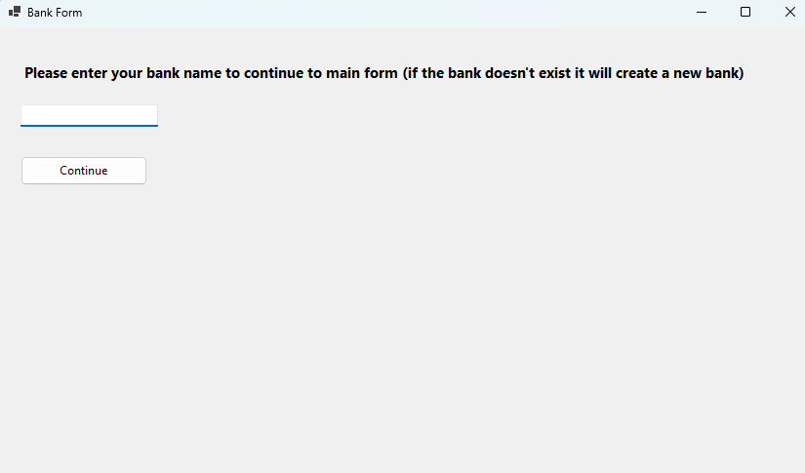
Figure 1 Bank Form
- Enter existing bank name or enter a new bank name to create one in the database

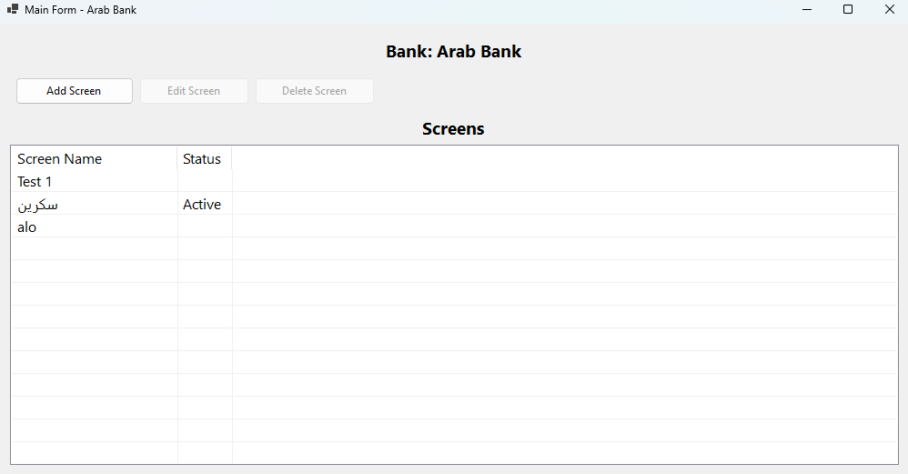
List of available screens
Screen Controls
Bank name
Figure 2 Main Form
- You can see the bank name you entered in the previous form, the controls for the screens as well a list of all available added screens and which screen is set as active.

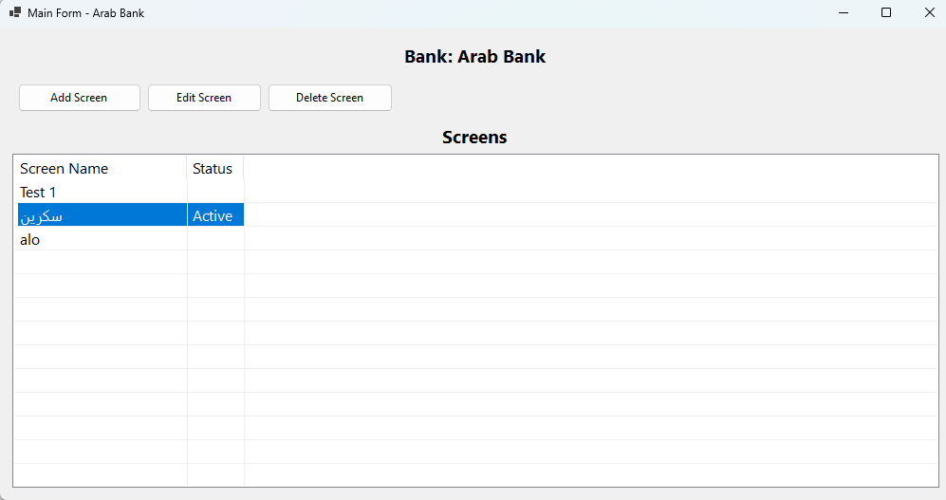
Figure 3 Highlighted Screen
- Highlighting one of the available screens activates the edit and delete buttons.

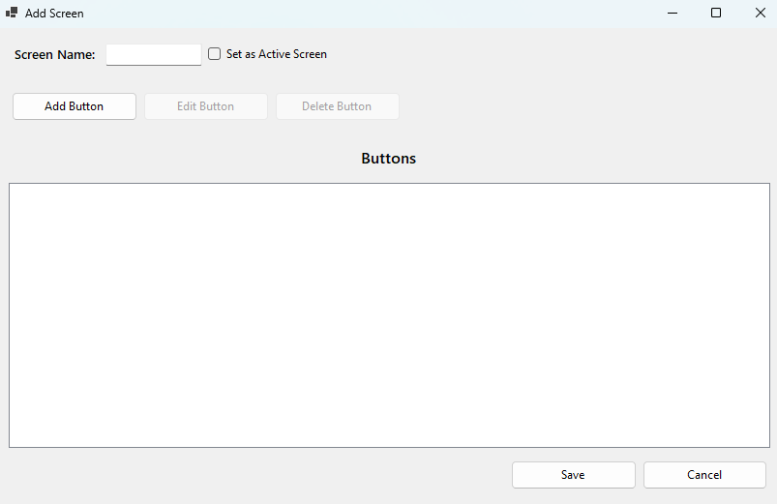
Save new screen or cancel (add screen) operation
Button Controls
Add Screen name and option to set it as active
Figure 4 Add Screen Form
- You can only have one active screen at one time.
- Proper validation setup so that you can’t save screen with no buttons.

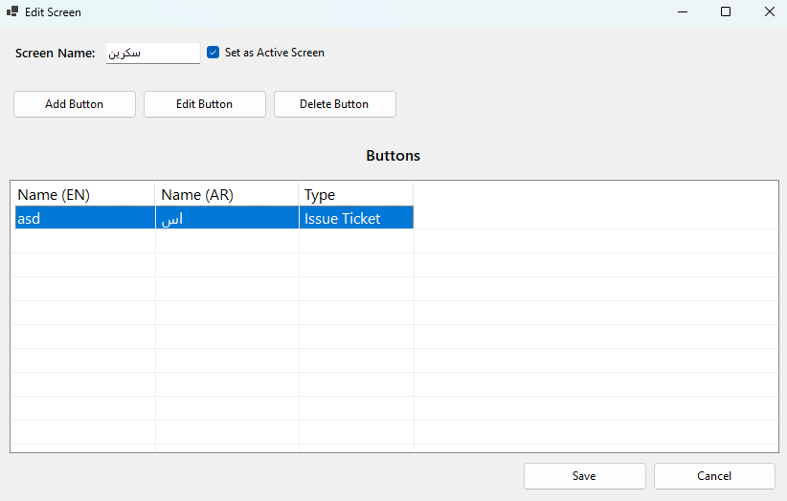
Button Name and Type
Edit Screen name and/or toggle active option
Figure 5 Edit Screen Form

- Edit screen name or keep it as is.
- Available buttons shown with the format:

English Button name | Arabic Button Name | Button Type

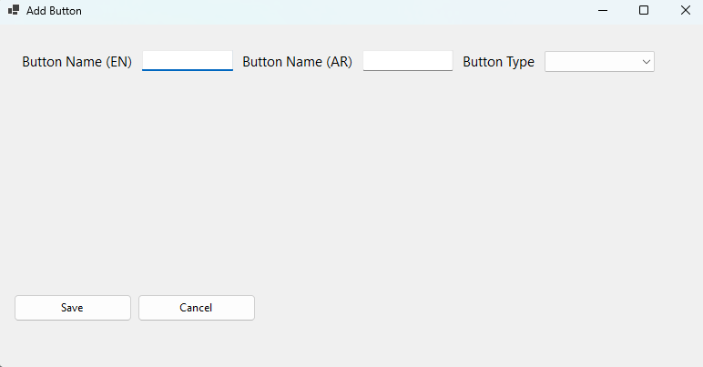
Specify Button name in both AR/ENG and button Type
Figure 6 Add Button Form

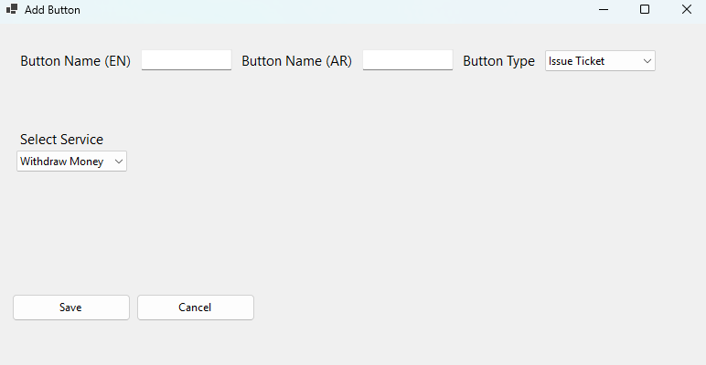
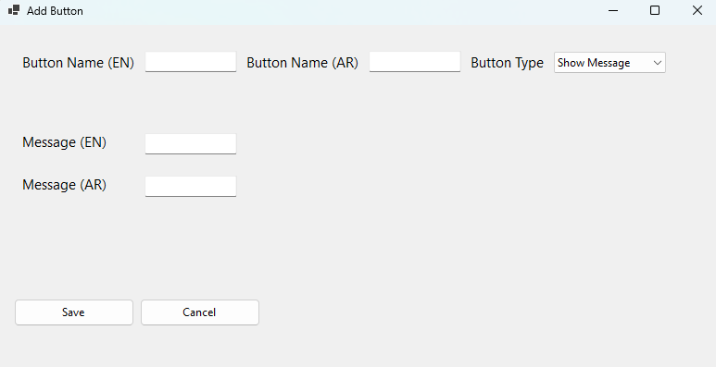
Figure 7 Add Button / Issue Ticket
Figure 8 Add Button / Show Message

- Only after selecting button type and filling the fields can you save the button.

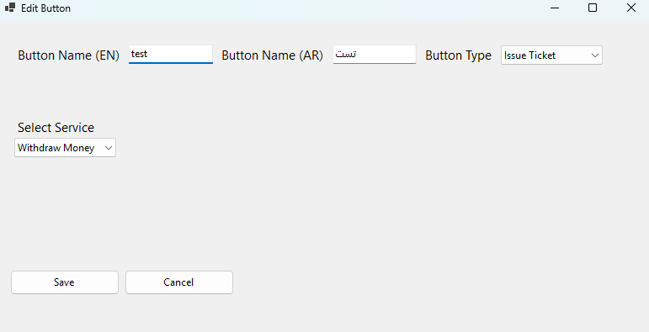
Figure 9 Edit Button Form

- Troubleshooting
Message Shown in App | What It Means / What to Do
Failed to connect to the database. Please check your network or database server. | The app couldn’t reach the database. Make sure:• SQL Server is running• Connection string is valid• Network is available
The operation timed out. Please try again later. | The request took too long to complete. Check for network or database performance issues.
An internal operation failed. Please try again. | An invalid operation was attempted (e.g., missing selection). Try again.
A file or disk operation failed. Please check file permissions or disk availability. | The app failed to access a file. Ensure it has write permissions to its directory.
An unexpected error occurred. Please contact support. | A general failure occurred. Check error_log.json in the app folder or contact support.
Configuration error. Please check your connection string settings. | The .config file is missing or the DbConnection setting is incorrect. Restore or update it.
Exiting application due to error. Please try again later. | A critical operation (like loading screens) failed. Restart or check logs.
App closes immediately on launch | Likely a missing or corrupted configuration file. Ensure .config has a valid connection string.
Database connection failed. Please check your server settings. | A SQL login error occurred. Verify credentials or authentication mode.
Nothing happens when clicking buttons | Could be a logic or state error. Restart the app. If issue persists, consult logs or contact support.

- Support
For further assistance, feedback, or to report issues, please contact the maintainer directly or open an issue in the project's designated repository.

